**29**. **Binomial Distribution**

**Aim :**

To Write an R program to study the Binomial Distribution using the following methods

1. **Using Formula**
2. **Using dbinorm,pbinorm,qbinorm,rbinorm ,**

**Algorithm :**

**Step 1 :** Start the process to find the Binomial Distribution using the mathematical formula and built-in functions (dbinom, pbinom, qbinom, and rbinom).

**Step 2 :** Define parameters: number of trials n, success probability p, and values of x to analyze.

**Step 3 :** Use dbinom(x, n, p) to calculate and print the probability of exactly x successes.

**Step 4 :** Calculate probabilities for multiple values of x (e.g., 0 to 4) and print each.

**Step 5 :** Use pbinom(x, n, p) to compute and print cumulative probabilities up to specific values of x.

**Step 6 :** Find probability between two points by subtracting two cumulative probabilities and print the difference.

**Step 7 :** Use qbinom(p, n, p) to find the smallest x for which cumulative probability exceeds p.

**Step 8 :** Generate and print random binomial samples using rbinom() with specified size and probability.

**Step 9 :** End the program.

**Program :**

x<-4

y<-dbinom(x,10,0.5)

print(y)

#dbinom

x<-0

y0<-dbinom(x,4,0.5)

print(y0)

x<-1

y1<-dbinom(x,4,0.5)

print(y1)

x<-2

y2<-dbinom(x,4,0.5)

print(y2)

x<-3

y3<-dbinom(x,4,0.5)

print(y3)

x<-4

y4<-dbinom(x,4,0.5)

print(y4)

y = y0+y1+y2+y3+y4

print(y)

#pbinom

x1 <- 2

y1 <- pbinom(x1,4,0.5)

print(y1)

x2 <- 3

y2 <- pbinom(x2,4,0.5)

print(y2)

y = y2-y1

print(y)

#qbinom

x <- qbinom(0.375,4,0.5)

print(x)

#rbinom

x<- rbinom(8,150,0.4)

print(x)

print(dbinom(0,size = 12,prob = 0.2)+

dbinom(1,size = 12,prob = 0.2)+

dbinom(2,size = 12,prob = 0.2)+

dbinom(3,size = 12,prob = 0.2)+

dbinom(4,size = 12,prob = 0.2))

print(pbinom(4,12,0.2))

**OUTPUT :**

1. **Using Formula :**

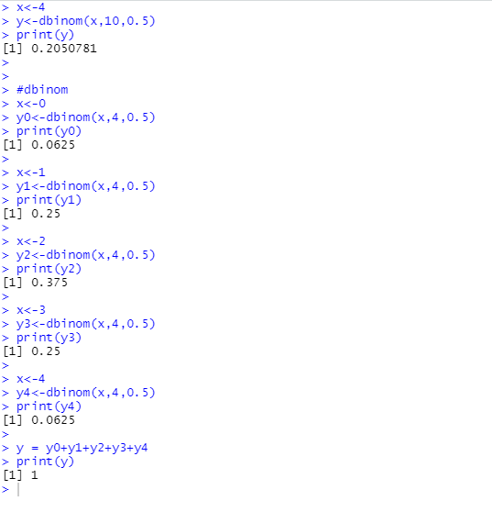

**b) Using dbinorm,pbinorm,qbinorm,rbinorm**

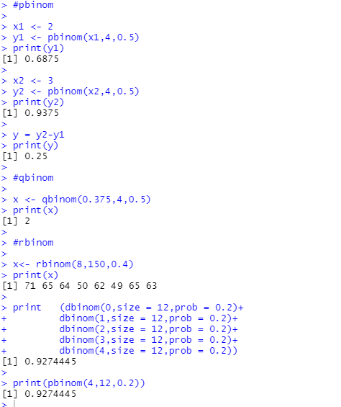

**RESULT:**

Thus, the program has been successfully saved and executed.